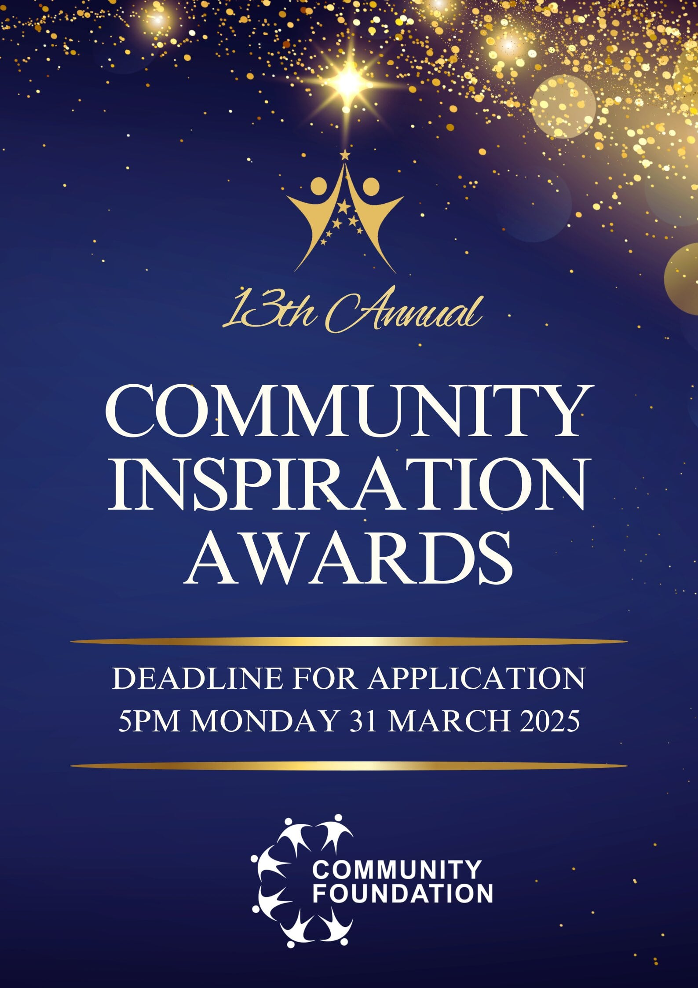


Nominations for the 13th Community Inspiration Awards 2025 are now open. The annual Community Inspiration Awards is organised by the Community Foundation, to recognise outstanding contributions made by staff from public sector organisations, charities, businesses and members of the community, whose efforts have made a positive difference in the community and has inspired and motivated others.

Each year, we are inundated with hundreds of applications from very high achieving individuals from the community, public sector organisations, charities, and businesses.

This year’s Community Inspiration Awards ceremony will take place in Birmingham on Friday 26th September 2025 where our panel of esteemed judges will announce the finalists and winners. Like previous years, awards will be presented by various dignitaries, including Chief Officers from public sector organisations, council leaders and Members of Parliament.

With 15 award categories to choose from, you can nominate somebody who you think deserves an award. Individuals can also submit a self-nomination, with the support of an independent verifier (basically, someone who can vouch for your good work!). Individuals can be nominated for more than one award category where applicable.

Deadline for application is Monday 31st March 2025.
You can complete the nomination form online at: https://forms.office.com/e/HCBqAekgfd

You can also complete the nomination form below and email back to:

info@thecommunityfoundation.org.uk

For further information visit our website: www.thecommunityfoundation.org.uk

or contact us:

Email: info@thecommunityfoundation.org.uk

Tel: 0121 312 0135

Award CategorIES
SERVICES CATEGORY
Awards for outstanding contributions by service providers.
- Community Reassurance Award
This award is to recognise the outstanding contribution made by a member of the Police Service or a policing team who have worked hard with the community to successfully improve community safety or reduce fear of crime.

- Public Services Award
This award is to recognise an outstanding contribution made by an officer or a team from the council or housing association by going the extra mile to respond to the service needs of the community and improve customer satisfaction.

- Fire Fighter Award
This award is to recognise an outstanding fire fighter or a team who have put their own lives at risk to save people/property from fire or who have worked hard to improve fire safety.

- Health & Well Being Award
This award is to recognise the significant contribution made by a health practitioner or a team to improve health and well-being of the community though their continuous dedication and commitment to help others going beyond their call of duty.

- Education Service Award
This award is to recognise an individual or a team who has been innovative in creating opportunities for people to get into education or complete their education who otherwise would not have studied/achieved the grades.

- Business & Enterprise Award
This award is to recognise businesses and social enterprises that have managed to ride the economic downturn or have made positive contribution to their locality and/or customers.

- Community Organisation Award
This award is to recognise an outstanding voluntary organisation that has made a positive impact on the community through their continuous dedication and passion to help the community.

COMMUNITY CATEGORY

Awards for outstanding contributions by members of the community.
- Lifetime Achievement Award
This award is to recognise the outstanding achievements made by a person throughout their lifetime and is an inspiration to others.

- Duty to the Community Award
This award is to recognise a politician or community activist for their dedication to serve the community through thick and thin to bring about improvements in their constituent area or to a community.

- Bringing People Together Award
This award is to recognise outstanding individuals or a group who have improved community cohesion by bringing together people from different backgrounds and cultures to work together.

- Environment Champion Award
This award is to recognise an individual or an organisation that has been helping to make positive improvements to the environment.

- Sports Award
This award is to recognise an individual who has excelled in sporting, or a club that has supported people to realise their full potential and sporting talent.

- Volunteer Award
This award is to recognise an individual who has dedicated their time and energy voluntarily to an organisation or cause through which they have made a significant difference in the community.

- Education Achievement Award
This award is to recognise students who have strived hard and made significant progress to achieve outstanding academic success in their study at school, college or university.

- Good Neighbour Award
This award is to recognise someone with a heart of gold, who is always on hand to help out and make everyday life better for their neighbours.

Community Inspiration Awards 2025
Nomination Form

Please fill in the details below and provide contact details so that we can contact the person/organisation nominated should they be shortlisted.

Details of person being nominated:
Full Name of Nominee:

Organisation (if any):

Address & Postcode:
Contact Number:
Email address:

Details of person making the nomination or independent verifier (if nominating yourself):
Full Name:

Job Title:

Organisation (if any):

Address & Postcode:

Contact number:

Email address:

Who are you nominating?
☐ Myself ☐ My organisation ☐ Someone else ☐ Another organisation

In what capacity do you know the nominee?

Please tick the box or boxes below for the nomination award category
Please see the previous page for award details.
You may nominate for more than one award.

COMMUNITY CATEGORY |  |  | SERVICES CATEGORY
1 | Lifetime Achievement Award ☐ |  | 1 | Community Reassurance Award ☐
2 | Duty to the Community Award ☐ |  | 2 | Public Services Award ☐
3 | Bring People Together Award ☐ |  | 3 | Fire Fighter Award ☐
4 | Environment Champion Award ☐ |  | 4 | Health & Wellbeing Award ☐
5 | Sports Award ☐ |  | 5 | Education Services Award ☐
6 | Volunteer Award ☐ |  | 6 | Business & Enterprise Award ☐
7 | Education Achievement Award ☐ |  | 7 | Community Organisation Award ☐
8 | Good Neighbour Award ☐

Please provide a detailed description of what the nominee has achieved by answering each question below (please ensure your response is 150 words max for each question)
What did the nominee do? You should mention what actions were taken, who did they work with/who benefitted, and when did it take place.

What was the impact? For example, did it raise awareness or make improvements, change behaviours and attitudes, receive feedback or recognition.

When was the activity/action carried out?

Why should the nominee be given the award in the chosen category/categories?

Is there anything else you would like to tell the judges about the nominee?

AGREEMENT BY PERSON NOMINATING or INDEPENDENT VERIFIER (if self-nomination is being made)

☐ I confirm that the details I have given are accurate to the best of my knowledge. I support the nomination of the named person in this application for the ‘Community Inspiration Awards’. (Please tick to agree).

Thank you for taking part in the nominations for the Community Inspiration Awards 2025 and for supporting this event. Your nomination will be assessed by our judges to consider if it can be shortlisted for the award category you nominated. We may also move the nomination to another award category, if the judges deem it appropriate. Judge’s decisions are final.

Please return the completed application before the deadline (Monday 31st March 2025) and email to: info@thecommunityfoundation.org.uk

For further information: Tel: 0121 312 0135
Email: info@thecommunityfoundation.org.uk

Web: www.thecommunityfoundation.org.uk www.facebook.com/communityfoundationuk
www.instagram.com/community.foundation/ www.twitter.com/comm_foundation

Privacy Notice
The Community Foundation will use the information that you provide only in relation to your request. We rely on the lawful basis of ‘legitimate interests’ to process your personal data only for the purposes of receiving, considering, and awarding nominations for the Community Inspiration Awards 2025.

