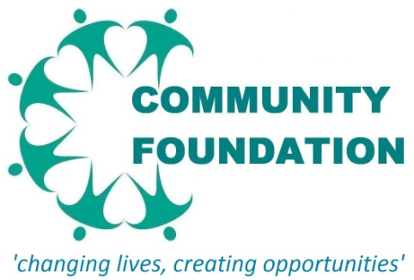



**“CHALLENGING, MOTIVATING & ASSISTING YOUNG PEOPLE ACHIEVE THEIR ASPIRATION”**



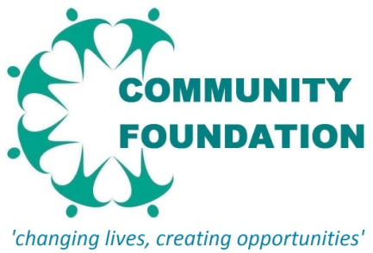

YOUTH MENTORING PROGRAMME

Mentor Registration Form

|  |  |
| --- | --- |
| First Name |  |
| Surname Name |  |
| Gender |  |
| Age |  |
| Job Title |  |
| Company Name And Address |  |
| Telephone |  |
| Mobile |  |
| Email |  |

**CAREER KNOWLEDGE AND EXPERIENCE**

|  |  |  |  |
| --- | --- | --- | --- |
| Please indicate the category that best describes your area of work (you may select more than one): | | | |
| Administration □ | Finance □ | Personnel □ |
| Arts & Cultural Industries □ | Government □ | Police □ |
| Brewing & Licensed Trade □ | Health & Beauty □ | Publishing □ |
| Chemical Industry □ | Hotels & Catering □ | Regeneration □ |
| Computing & IT □ | Insurance □ | Retail □ |
| Construction & Surveying □ | Law □ | Security □ |
| Design □ | Voluntary Sector □ | Science & Tech □ |
| Education □ | Market Research □ | Social Services □ |
| Engineering □ | Marketing & Sales □ | Sports & Leisure □ |
| Environment □ | Media □ | Training □ |
| Fashion & Textiles □ | Medicine & Dentistry □ | Management & Consultancy □ |
|  | | |

**Please briefly describe the main functions of your current post:**

**Ethnicity:** (please tick the box which best describes your ethnic origin)

**White**

English □ Welsh □ Scottish □ Northern Irish □   British □  Irish  □

Any other White background, please describe

**Mixed / Multiple ethnic groups**

White and Black Caribbean  □   White and Black African □  White and Asian □

Any other Mixed / Multiple ethnic background, please describe

**Asian / Asian British**

Indian □  Pakistani □    Bangladeshi  □  Chinese □  
 Any other Asian background, please describe

**Black / African / Caribbean / Black British**

African  □  Caribbean  □ Black British □

Any other Black / African / Caribbean background, please describe

Arab □

**Mentoring Preferences (tick a box to indicate the type of mentee you are able to support)**

**Mentee Gender Preference**

Male □ Female □ No Preferences □

**Mentee Ethnicity Preference**

White □ Asian □ Black □ Arab □ No Preferences □

**Mentee Profile Preference**

studying/training □ non problematic □ ex drug user □ ex offender □ No Preferences □

|  |
| --- |
|  |
|  |
| **Please describe any knowledge or experience you have of mentoring, counselling or coaching.** *This might be from your professional or personal life. Although it is not essential to have prior mentoring experience, this information will assist in our matching process.* |

**What is your motivation for applying to be a mentor? What do you hope to achieve from it?**

Although we will try to match you with a mentee who is particularly interested in your field of work, this is not always possible. Our main aim is to find professionals who will be able to facilitate their mentee's personal and professional development.

**MENTOR DECLARATION**

□ I will contribute to the Community Foundation Mentoring Scheme to the best of my ability and will at all times act in accordance with the aims of the Scheme.

□ I will keep in regular contact with my mentee and will inform the Mentoring Coordinator if I there is any change in circumstances.

Signature: .............................................................................................................................................

Date: ....................................................................................................................................................

Please forward your completed application form to:

Via email to: info@thecommunityfoundation.org.uk

Via post to : Community Foundation, The Union Building, 148 Gerrard Street, Birmingham B19 2DR

Tel: 0121 572 5154

For any further information visit our website: www.thecommunityfoundation.org.uk

